North London Community Fund 2026-2027
Micro, Small and Medium Grants

This guidance document provides important information to help you apply for a micro, small or medium grant. If you have any queries, please email the team at North London Waste Authority on the following address: wastepreventionteam@nlwa.gov.uk

Information in this document
1. What funding is available 3
2. Who is eligible to apply 3
3. What the fund will cover 4
4. Where the projects take place 5
5. Timeline for applications and decisions 5
6. How to apply 6
7. How applications are evaluated 6
8. Successful applications 8
9. How grants are paid 9
10. Support for organisations receiving a grant 10

What funding is available
The North London Community Fund (NLCF) grants are available to support projects that aim to reduce waste created in homes. The types of projects supported might provide activities, tools, skills or information to help change people’s behaviours, so they waste less. It may also educate people on how to dispose of waste properly using local services or find useful ways to get rid of things they no longer use. Grants can be put towards project goods, staff time or other costs required to run an activity.

You can read about all the previously awarded projects on our website at the following link North London Community Fund summary of projects.

The timeline for when the fund opens and closes for applications and when grants are due to be awarded is set out later in this document and on our website at the following link North London Community Fund – how to apply. If you are experiencing difficulties with accessing or completing the application form, please email us on wastepreventionteam@nlwa.gov.uk for advice and support.

Total funding available for micro, small and medium grants is £175,000 per year. The number of grants awarded in each grant size will be decided during the evaluation phase.

Grant size: | Maximum amount per project: | Timeframe for delivery of project:
Micro grants | Up to £1,500 | Up to 1 year
Small grants | Up to £5,000 | Up to 1 year
Medium grants | Up to £20,000 | Up to 2 years

Who is eligible to apply
The fund is designed to support not-for-profit organisations, and we have listed below the types of organisations that are setup in this way. If your type of organisation is not included here but you believe it fits the criteria and you wish to apply, please email us to discuss.

□ Charitable Trust | □ Community Interest Company
□ Unincorporated Association | □ Company Limited by Guarantee
□ Community Benefit Society | □ Charitable Incorporated Organisation
□ Charitable Company

Organisations must have their own bank account to apply for this funding. If your organisation does not, you can join with another not-for-profit organisation that has a bank account to make the application, and they could receive the funding for the project on your behalf.

Organisations can apply on their own or can partner with other organisations to make a joint application so that they can deliver the project together. Please keep in mind that only one application is accepted per organisation each year.

We welcome applications from organisations who have applied before, that includes those who have and those who have not been successful in getting a grant from us.

What the fund will cover
We have been delighted to invest the fund into a wide variety of projects over the years and are always impressed by the creativity and commitment we see presented in applications. The fund is designed to support projects that help residents to reduce waste, get the best from the things they own or food they buy, and reuse, repair or dispose of household items in the most environmentally conscious ways. We do not try and describe every type of project that could be supported because each organisation will want to create a tailored approach to meet their community’s needs. You can see examples of previous projects on the North London Community Fund summary of projects page of our website. However, to help you decide if your project idea is suitable for this fund, we have included below the types of projects that it does not cover.

What the fund does not support:

X Research projects. | X Projects delivered by a local authority.
X Projects delivered by a school. | X Project applications from profit-making businesses.
X Projects delivered in schools during term time or within school times. | X Projects for which full funding has already been received from another source.
X Projects designed to only reduce waste from a business. | X The cost of work or activity that an organisation or individual has a duty to do.

Where the projects take place
The fund is designed to support communities in the North London Waste Authority area which is made up of the following boroughs - Barnet, Camden, Enfield, Hackney, Haringey, Islington and Waltham Forest. The proposed project must take place in at least one of these boroughs.

Timeline for applications and decisions
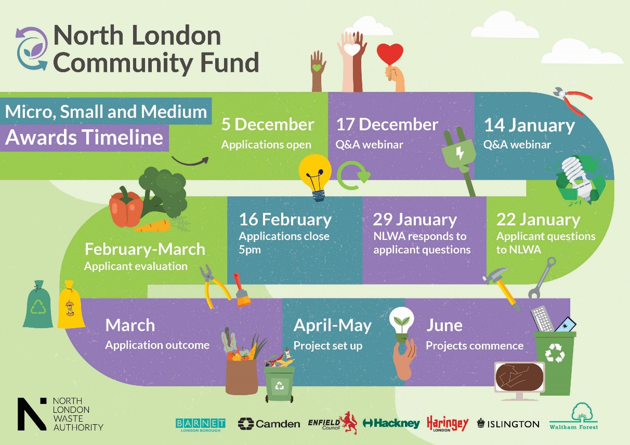

How to apply
Applicants must complete the North London Community Fund online application form which is available on the following webpage North London Community Fund – how to apply. You will find detailed guidance there on how to fill it in.
If you are experiencing difficulties with accessing or completing the application form, please email us on wastepreventionteam@nlwa.gov.uk for advice and support.
To be fair to all applicants, we will only be able to provide help with general enquiries and cannot answer questions related to specific project ideas or approaches. If you need to clarify something about the fund, perhaps you are unsure of some wording we use or want to check if your organisation is suitable to apply, you can email us to the address above to ask. The answers to those types of questions are often useful for other people to know too so we publish them on our website, totally anonymously, whilst the fund is open. We often use those questions to help inform and improve how we deliver this work.

How applications are evaluated
Each year we create an evaluation team that will be made up of NLWA staff and individuals invited from community organisations in north London, in consultation with officers from the north London boroughs. The evaluation team members will bring diversity in experience, backgrounds and expertise to the evaluation process. They will create a shortlist of project applications that could be awarded. That process can last numerous weeks depending on how many applications are received. The timeline for this round of funding is presented in an infographic in section 5 of this document and in a plain text version on our website at the following link North London Community Fund – how to apply.

Applicants will be notified by email of the outcome of the application, whether successful or unsuccessful, once all the evaluations have been completed. Feedback will be provided if your application was unsuccessful and we will be available for a telephone call to discuss further.

The highest scoring projects will be funded up to the value of either £1,500, £5,000 or £20,000. The number of projects that will be awarded will be determined during the evaluation phase.

Projects will be assessed against the criteria below: C1- C4
We have included questions to help guide what you could include in your application
Use this section to help you write about your project delivery plan (design, people, timelines and risks)
□ C1: Planning of the project and whether it is achievable within the proposed timeframe. | - What are the main activities and when will they happen?
 | - Who will deliver the project, and what relevant experience or partnerships do they bring?
- What risks might affect delivery and how will you manage them?
- What is the project timeline and key milestones
Use this section to help you write about your project outputs and measurement (how are you going to measure the outputs of the project to show the impact)

□ C2: What results the project aims to achieve, and how they will be measured and communicated. | - What specific outcomes will your project achieve (e.g., how many people do you plan to engage with, how many workshops/events will you run)?  - How will you collect data, feedback or evidence to measure the outcomes?
Use this section to help you write about your project engagement plans (what will you do to engage north London residents)

□ C3: How the project will involve, support and inspire north London residents, communities or groups to take part in waste prevention activities. | - Who will your project engage or support, and how will you ensure your activities are inclusive and accessible to different communities?
Use this section to help you write about project resources needed (what are you going to spend the funding on)

□ C4: How the project's resources (funding, partnerships, time and people) are planned. | - Is your budget realistic for what you plan to deliver?
 | - If you are buying equipment, is it essential and good value?
 | - Please provide as much detail as possible in relation to each item.
 | - Staff time can be charged up to a maximum of £20 per hour.

Successful applications
When the evaluation process is finished, we will need to check some information about the organisations that have been shortlisted before we can finally decide to give the grants. We will email those organisations to let them know what needs to be checked. We will attach a letter with that email, that is known as the ‘provisional award letter’.
The information we will require from you will be written out in the provisional award letter. All shortlisted applicants will be asked to provide the information listed below. We may ask for additional specific information relevant to your project.
□ Public Liability Insurance for proposals that involve the use of a venue or locations.
□ Employers Liability Insurance unless the applicant has statutory exemption for this type of insurance.
□ A copy of accounts or financial statement for the last financial year relating to the organisation applying. If you are a new or small organisation, or if you need support with this request, we can guide you on what to provide.
□ A recent bank statement or official document showing details of bank account

When all the required information has been sent back to us, we will check it to make sure it is correct and then notify you of the final decision by letter. This is known as the ‘award letter’ and will be sent to you by email.
For best practise we also recommend that organisations have the following organisational policies in place, but it is not a requirement of the application. We have included links to policy templates to help you create your own if needed.
□ Environmental policy
□ Health and Safety policy
□ Equal opportunities policy

How grants are paid
We intend to make payments for the awarded grants as follows.
Micro and small grants (£1,500 - £5,000): Total amount is paid at the start of the project.
Medium grants (£5,000 - £20,000): First payment, 80% of the total value of the grant is paid at the start of the project.
These payments are made when:
□ All information requested in the provisional award letter has been sent to us by your organisation and we have reviewed and approved it.
□ The funding agreement that will be emailed to successful applicants is signed by a representative of your organisation and North London Waste Authority.
□ The project kick-off meeting has been held between representatives of your project and our team.
Medium grants: Second payment, for 20% of the total value of the grant is paid once the final monitoring report, final financial report and the final case study have been submitted and agreed by us. These reporting requirements will be explained during the project kick-off meeting, and we will support you throughout the project to gather the information needed.

Support for organisations receiving a grant
We work closely with the organisations we give grants to and offer a range of support while they are delivering the projects. Organisations will have two points of contact at NLWA, one from the Waste Prevention Team who will be there for advice and general support while you deliver the project. Also, your organisation will have direct support from an NLWA Communications Officer to help promote your work. Below is an overview of the standard support that will be on offer.
Project kick-off meeting: Once you have been awarded a grant, we will get in touch to set-up a meeting to start the project. During this meeting we will talk through your application and review the key milestones that you have set to help you monitor how it is progressing. Also, we’ll talk through the targets you’re planning to reach. Depending on the size of the grant you are receiving, we may also book in other meetings for the mid and end points of your project.
Reporting project outcomes: You will be guided at the project kick-off meeting as to what data and evidence you are required to gather while delivering your project. This information will help you show how you are meeting the targets you have set for your project. You may also be asked to track financial information including keeping receipts for project items you’ve purchased. Full guidance and support will be provided for this.
Promoting project activities: We will provide support for promoting your project, such as advertising your events via social media and on our website. We may also offer to attend events with a photographer to get photos of it in action. We could also offer to write an article for a local newspaper or a blog about your work.
Outreach and engagement: Supporting communities with information and guidance on how to waste less and get the most from the things we own and food we buy is a key offer for community groups. This could be delivered through one of your group sessions, community events or a workshop for your organisation.
Networking events: We run informal events where organisations who have been given a grant can meet with others. These are great opportunities to meet others, celebrate achievements and showcase the work that you are doing. We have seen successful collaborations between awarded groups start from these events.
Training opportunities: We will plan sessions designed to enhance skills and knowledge for groups receiving an award; the training may cover a range of topics from organisational strategy to data protection and social value.

This guidance document provides important information to help you apply for a micro, small or medium grant. If you have any queries, please email the team at North London Waste Authority on the following address: wastepreventionteam@nlwa.gov.uk

