Appendix F Technical Assumption Book

Derivation of project option costs for the Reference Case

Land prices

Site & Planning | Cost of Land £m | Timing to be modelled
Pinkham Way 1st Site | 13.8 | 3rd Qtr 09/10
Pinkham Way 2nd Site | 4.5 | 1st Qtr 11/12
CRL Site | 6.032 | 3rd Qtr 9/10
Hendon (Bestway CPO) Site | 20 | 3rd Qtr 11/12
CA Sites | 9.3663 | 1st Qtr 10/11
Bronte Site | n/a | n/a
Planning | 1.25 | 4th Qtr 9/10
Planning | 1.25 | 1st Qtr 10/11
Total | 56.1983

Revenue assumptions

Dry recyclates

The dry recyclate values have been based on the following distribution of material and prices. A graph of the average pricing based on the distribution of materials currently recycled is shown in Figure 1. Table 1 below shows the value based on the long-term average values and indicates that an average value of approximately £37 for dry recyclates could be achieved based on past prices. However, these prices are based on a long-term market where demand is in balance with supply; whilst there are fluctuations in prices, the values tend to remain stable. A large proportion of this value derives from the aluminium content and introduction of drawn ferrous drinks cans is increasing and may well reduce values in the long term. However, government pressure on recycling targets will inevitably increase the supply of materials to the reprocessors. This will have a negative impact on prices owing to supply exceeding demand. Accordingly, it could be expected that prices might decrease. However, the government has recognised the issue and created the Waste Resources Action Program (WRAP) programme which is set up to identify and promote recyclate markets.

However in long term contracts of a PFI/PPP nature, contractor guarantees on recyclate value have not been observed to be given above £20/t in the projects that AEA have been involved in and this value has been used in the modelling. However, this indicates that there is some upside risk associated with this assumption and income to the council may be higher in reality than is modelled.

Figure 1 Blended recyclate price Oct. 2000-July 2007

Table 1 calculation of blended dry recyclates value based on long term average pricing
Fraction | % of recyclates | Market value | Contribution to blended price
Fraction | % of recyclates | £/t | Contribution to blended price
News and pams | 28.7% | £42.78 | £12.28
Mixed papers and board | 19.0% | £23.80 | £4.52
Brown cardboard | 3.0% | £47.00 | £1.41
Mixed glass | 11.9% | £13.26 | £1.58
Flint glass | 1.0% | £27.56 | £0.28
Amber glass | 1.0% | £23.94 | £0.24
Green glass | 2.0% | £14.68 | £0.29
Textiles | 2.4% | £51.09 | £1.23
Batteries | 0.0% | £28.32 | £0.00
Fe cans | 4.4% | £85.31 | £3.75
Aluminium | 1.6% | £656.17 | £10.50
CA metals | 4.6% | £28.24 | £1.30
Plastics | 3.0% | £54.46 | £1.63
Timber | 8.1% | -£10.06 | -£0.81
Aggregates | 9.3% | -£10.00 | -£0.93
Blended rate | 100.0% |  | £37.27

Electricity Market

The base cost of power has increased in recent years due to the influence of higher raw energy costs and supply and demand pressures in the domestic market. The graph below clearly indicates the rise of base power prices to consumers over recent years.

It is unlikely that the rate of rise over the last three years will continue and industry experts are predicting a slower but continued, above RPI, increase in power in the medium term.

Prediction of base power cost for more than two or three years ahead of the current time are prone to significant error margins and domestic and overseas political risk. As has recently been seen, short term disruption of gas supplies can lead to very significant shifts in the base cost of power supply.

The most recent energy trends report issued by DECC (June 2009) clearly examines the main energy issues faced by the UK at this time.
The main points for the first quarter of 2009:
- Total energy production was 4 per cent lower than in the first quarter of 2008.
- Oil production fell by 2½ per cent compared to the first quarter of 2008. Production from older established fields continued to decline but this decline was partially offset by eight new fields.
- Natural gas production was 12 per cent lower compared with the first quarter of 2008. Gas imports and exports increased by 7½ and 62 per cent respectively. The UK was a net importer of gas in the first quarter of 2009 by 105.5 TWh compared with 109.2 TWh in the first quarter of 2008.
- Coal production was 10 per cent higher than a year earlier. Coal imports were 13 per cent higher than a year earlier. Generators’ demand for coal was up 10 per cent.
- Total primary energy consumption for energy uses fell by 4 per cent in the first quarter of 2009 compared with the same period of 2008. When adjusted to take account of weather differences between 2008 and 2009, primary energy consumption fell by 7 per cent. The average temperature in the first quarter of 2009 was 4.9 degrees, 0.2 degrees below the long term average of 5.0 degrees between 1971 and 2000, and 1.1 degrees below that recorded in the first quarter of 2008.
- Final energy consumption fell by 4½ per cent between the first quarter of 2008 and the first quarter of 2009, with falls in all sectors.
- Industry demand has fallen sharply compared to a year earlier, with falls in the use of both gas and electricity of over 5 per cent. In particular energy demand from the iron and steel industry has contracted sharply.
- Coal supplied 12 per cent more electricity than in the same period a year earlier, while gas supplied 22 per cent less. Nuclear supplied 17½ per cent more. Net imports of electricity were a quarter of the level of a year earlier.
- Gas demand was 9 per cent lower than a year earlier, with a sharp fall in gas used for electricity generation. There was a fall in domestic consumption, despite the colder weather particularly in January and February. A contributory factor to this fall in demand is likely to have been domestic gas prices which were up by around a third in the first quarter of 2009 compared to a year earlier.
- Electricity consumption was 5 per cent lower than in the first quarter of 2008.

Over the last few years UK oil, gas and coal production has dropped and imports increased. It is unlikely that within the next 20 years major new sources of base load fuel chain will reverse these trends. When you then consider the uses of these raw fuels in power production you can see how dependent the UK is on imported fossil fuels. The recent suggestions of an increase in Nuclear power are unlikely to make a significant impact on our dependence on imported fuel in the short to medium term.

Figure 2 Production of indigenous primary fuels

When the above production of primary fuel figures are compared to their use in electrical generation it can clearly be seen that cost of base load production is likely to continue to increase as import dependency increases. The following chart (DTI) shows what proportions of primary fuel are used in electrical power generation.

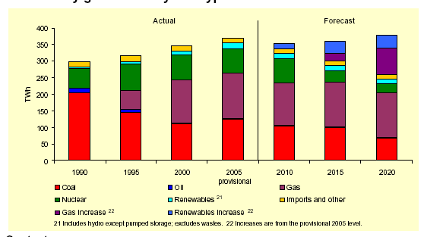

Figure 3 Electricity generation by type - UK projections

So whilst the cost of power production is likely to continue to grow, there is a general expectation that use of electrical energy is unlikely to drop and may grow slightly going forward. The following graph from the DECC energy trends report clearly demonstrates the static in power consumption within the UK.

Figure 4 UK Power consumption

Short term power price variance for last year is admirably demonstrated in the graph presented below. The total cost of electricity is constructed from two major components. Approximately 35% of the costs are made of system and distribution costs that are directly regulated by the Government and reviewed on average every 4 years and the remaining 65% made up from the market price of power.

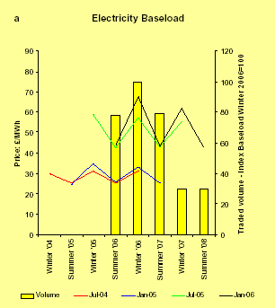

Figure 5 Forward electricity prices (DTI Energy Trends Jun 2007)

Data from recent bid processes have indicated a range of bid prices as the constraints on some projects are linked to existing power purchase agreements. These range from £30/MWh, 32/MWh to £40/MWh. Given the strong demand and expectation on pricing the modelling has assumed a value of £38/MWh, which is within range of pricing observed.

ROCs Values
The average value of ROCs is derived from the current trading values are around £45.50/MWh including LEC (Figure 6). However, long term the values are uncertain and discounting of this value and a total value for the ROCs and LECs associated with the energy is assumed to be £35.76/MWh. It has been assumed that 2 ROC/MWh for Biogas and 1 for CHP projects will be provided in line with the proposals and changes to the Renewables Obligation system. Alongside this the biomass content of 50% has been assumed for combustion, whilst biogas is 100% biomass.

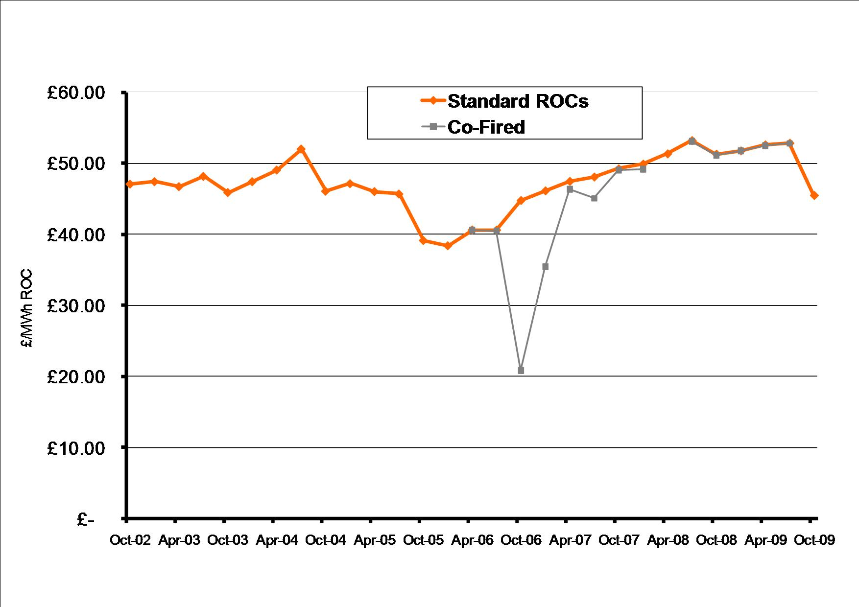

Figure 6 Average ROC auction prices

Heat price
A specific heat price has not been assumed but heat sales are set in the model at a level that balances any electricity income lost through heat generation.

Capital and operating costs

The technical solution has been determined using AEA’s proprietary WASTEFLOW model, which models the arisings in each collection authority and then models the flows of wastes through each process (MRFs, composting, AD and landfill, etc).

The capital and operating costs for each facility have been estimated using data from a range of sources including recent bid information, published studies and bottom up design costs available to both Ramboll and AEA. The information base services such as labour, reagents etc are checked against other sources where possible but the most recent data sources are more heavily relied upon and these are bids from recent PFI type contracts such as Cornwall, Northumberland and West Sussex. The costs are based on a mixture of fixed and variable cost elements and the variable costs will be those that are directly related to the amount of waste processed. Fixed cost elements tend to be related to the size or scale of the facility irrespective of the use of the plant, these items would be maintenance, business rates, insurance etc. These are based on factors of the plant capital costs (e.g. business rates costs is based on a 1% percentage of the civil engineering costs and insurance is a further 1%). In a similar way the capital costs are based on primarily bid information but can be supplemented by information from published data to enable scaling approaches to be developed to allow the cost from different projects to be developed and generally involves the development of a cost curve that relates plant scale to cost. This can be modified by the use of modular facilities where plant is provided in modules of a set capacity and cost. It should be noted that these estimates are based on historical data and movements in the market can affect the final bid prices. The results of the costs used in the modelling have been “truth tested” against other information and others in the Advisor team who have access to other bid information sources.

Currently, the UK is facing substantial pressures in the waste management equipment supply market and prices are increasing. Examples from recent bids show that capital prices can vary for similar facilities of up to 30% between bidders, but overall prices are increasing sharply. Thus, the estimates reflect a best estimate of the costs of the performance specifications on current evidence, but this may not be the price that is obtained in the final negotiated contract.

The capital and operating costs have been determined on the basis of a mid-2009 baseline and the operational costs provided, as the financial inputs, do not include inflation. The scale (operational capacity) of the processing facilities varies due to the amounts of material collected for recycling and composting under the different collection arrangements. However, it should be noted that these operational capacities may not be fully utilised throughout the contract period. In practice some of this spare capacity may be taken up by third party waste thereby reducing costs, but the current modelling assumes no additional inputs to “backfill” spare processing capacity.

The detailed derivation of capital and operating costs for sample AD, MRF, EfW and MBT-AD in the Project Options modelling are given below.

Materials recovery facility
- Capacity of the facility is set at 100ktpa, essentially a single line of a processing style facility for the co-mingled collection.
- Capital expenditure £12.3m 24 month construction completion by end of 2015/16.
- Life cycle capital expenditure is set at 10% of M&Es cost every 7 years and 3% of civil engineering expenditure every 7 years

100 ktpa capacity | £million
Civil Engineering | £6.4
Mechanical & Electrical | £5.4
Development | £0.4
Total | £12.2

- Operational costs are calculated as shown in Table 2.

Table 2 Operational cost of 100ktpa MRF at Hendon
MRF | 70,000 tonnes | £
Staffing | 36 @ £31k | 1,118,286
Consumables fuel, power | £2.15 /t | 215,378
Maintenance | 1 % Civil Eng 3.5 % M&E | 254,654
Insurance, permits etc | 1 % capital, plus Subsistence costs | 158,154
Overheads | 17.5 % of staffing costs | 195,700
Transport product to market | 45 km for product to market @ £0.17 per t/km | 726,750
Transport rejects to landfill | 32 km for reject to landfill @ £0.17 per t/km | 27,200
Vehicles on site | 2 vehicles @ £50k each | 100,000
Total (excluding operating margin) |  | 2,796,122
Operator margin | 12.5 % of operating costs | 349,515
Total (including operating margin) |  | 3,145,637
Average operational cost | £/tonne | 31.46
Revenue from recyclates | £37 /t | 3,515,000
Average revenue | £/tonne | 35.15

Prior to the new MRF facilities becoming operational, collected material is sent to third party markets at a gate fee similar to those currently experienced in the NLWA area (£32/t).

Green waste composting
This is assumed to continue to be a gate fee contract with specialist third party composters and a gate fee of £25/t has been assumed. The costs of transport of this material is primarily incorporated into the base year net operating cost of each HWRC which are extrapolated upwards on a £/tonne basis.

Biowaste treatment
- Nominal capacity for anaerobic digester set to 112ktpa, although building of facility phased as additional capacity required.
- Capital cost £12.3m 24 month construction ready by end of 2015/16

112 ktpa capacity | £million
Civil Engineering | £3.1
Mechanical & Electrical | £8.8
Development | £0.4
Total | £12.3

- Life cycle capital expenditure is set at 1% of M&Es cost every 4 years and 3% of civils expenditure every 7 years and 5% M&Es cost every 7 years.
- Operational costs are set out in Table 3.

Table 3 Operational; cost calculation for 112ktpa AD facility
AD | 112,000 | £
Staffing | 15 @ £28,688k | 430,321
Transport compost to market | 70% @£0.17/tkm, 50km | 666,400
Transport compost reject to landfill | 5% @£0.17/tkm, 23km | 21,896
Operating costs |  | 300,000
Total (excluding operating margin) |  | 1,418,617
Operator margin | 12.5 % of operating costs | 177,327
Total (including operating margin) |  | 1,595,944
Average operational cost | £/tonne | 14.25
Income from electricity | 75KWh/t at 3.6p per unit | 425,600
 | plus double ROCS | 801,024
Average revenue | £/tonne | 10.95

Prior to the new AD facility becoming operational kitchen waste has been assumed to be collected and is sent to third party markets at a gate fee similar to those currently experienced in the NLWA area (£48.97/t).

MBT-AD

Capacity 240ktpa
Overall capital cost £85.5 million
Lifecycle costs based on £386k on a 7 yearly cycle and £7.02m every 7 years

240 ktpa capacity | £million
Civil Engineering | £12.9
Mechanical & Electrical | £70.2
Development | £2.4
Total | £85.5

Operational costs are as set out in Table 4.

Table 4 Operational cost for a 240ktpa MBT-AD
Operating costs | Rationale | Costs
Staffing | 25 @ £38k | £946,950
Consumables fuel, power | £5.47 /t | £1,312,747
Maintenance | 1 % Civil Eng 2.5 % M&E | £1,883,575
Insurance, Rates, permits etc | 1 % M&E 1 % civils, plus Subsistence costs | £850,650
Overheads | 17.5 % of staffing costs | £165,716
Transport recyclate to destination | 168 km for recyclates to destination @ £0.17 per t/km | £410,040
Transport SRF to 3rd party | 8 km for RDF to destination/landfill @ 0.17 per t/km | £178,541
Transport residue to destination/landfill | 8 km for residue to destination/landfill @ 0.17 per t/km | £57,773
Shredding of CA and Bulky waste | £1.5 /t | £10,440
Vehicles on site | 4 vehicles @ £50k each | £200,000
RTO Operation | £2/Nm3 | £720,000
Total (excluding operating margin) |  | £6,736,432
Operator margin | 12.5 % of operating costs | £842,054
Total (including operating margin) |  | £7,578,486
Average operational cost | £/tonne | £31.58
Electricity | £38 /MWh | £684,000
Heat | £6.5 /MWh | £0
ROCS | £71.52 /MWh | £1,287,360
Recyclates | £20 /t | £288,000
Total |  | £2,259,360
Average revenue | £/tonne | £9.41

MBT-AD

Capacity 345ktpa
Overall capital cost £102.9 million
Lifecycle costs based on £479k on a 7 yearly cycle and £8.4m every 7 years

345 ktpa capacity | £million
Civil Engineering | £16.0
Mechanical & Electrical | £84.0
Development | £2.9
Total | £102.9

Operational costs are as set out in Table 4.

Table 5 Operational cost for a 345ktpa MBT-AD
Operating costs | Rationale | Costs
Staffing | 31 @ £38k | £1,174,218
Consumables fuel, power | £5.47 /t | £1,887,073
Maintenance | 1 % Civil Eng 2.5 % M&E | £2,259,500
Insurance, Rates, permits etc | 1 % M&E 1 % civils, plus Subsistence costs | £1,019,500
Overheads | 17.5 % of staffing costs | £205,488
Transport recyclate to destination/landfill | 168 km for recyclates to destination/landfill @ £0.17 per t/km | £591,192
Transport SRF to 3rd party | 35 km for RDF to destination/landfill @ 0.17 per t/km | £1,118,363
Transport residue to destination/landfill | 23 km for residue to destination/landfill @ £0.17 per t/km | £238,764
Shredding of CA and Bulky waste | £1.5 /t | £15,008
Vehicles on site | 5 vehicles @ £50k each | £250,000
RTO Operation | £2/Nm3 | £1,035,000
Total (excluding operating margin) |  | £9,794,106
Operator margin | 12.5 % of operating costs | £1,224,263
Total (including operating margin) |  | £11,018,369
Average operational cost | £/tonne | £31.94
Electricity | £38 /MWh | £983,250
ROCS | £71.52 /MWh | £1,850,580
Recyclates | £20 /t | £414,000
Total |  | £3,247,830
Average revenue | £/tonne | £9.41

SRF Combustion Plant

Capacity 320ktpa
Overall capital cost £226 million
Lifecycle costs based on £1.22k on a 7 yearly cycle and £8.04m every 5 years

320 ktpa capacity | £million
Civil Engineering | £60.8
Mechanical & Electrical | £160.7
Development | £4.5
Total | £226.0

Operational costs are as set out in Table 6.

Table 6 Operational cost for a 320ktpa SRF plant
Operating costs | Rationale | Costs
Staffing | 42 @ £42k | £1,764,000
Consumables fuel, power | £3.5 /t | £1,120,000
Maintenance, M&E | 2.5 % M&E | £4,017,500
Maintenance, Civils | 1% of Civil | £608,000
Insurance, Rates, permits etc | 1% of CAPEX | £2,260,000
Overheads | 17.5 % of staffing costs | £308,700
Transport bottom ash to landfill | 25km/£0.17 per t/m | £30,600
Transport bottom ash recycled to market | 25km/£0.17 per t/m | £173,400
Transport fly ash to disposal | 50km/£0.17 per t/m | £108,800
Ash processing | £15/t | £612,000
Vehicles on site | 2 vehicles @ £50k each | £100,000
Total (excluding operating margin) |  | £11,103,000
Operator margin | 12.5 % of operating costs | £1,387,875
Total (including operating margin) |  | £12,490,875
Average operational cost | £/tonne | £39.03
Electricity | £38 /MWh | £8,998,400
Heat | £2.38 /MWh | £494,000
ROCS | Dealt with within Massflow.model (see ‘ROC’s value’ section above). | £3,979,945
Total |  | £13,472,345
Average revenue | £/tonne | £42.10

Rail Transfer Station
The following figures are based on estimates by Ramboll WhitbyBird and AEA. The figures are based on discussions with the industry and suppliers. Much of the cost of rail connection is site specific and the best estimates can be arrived at only after engaging with Network Rail.

- Capacity 300ktpa

It is expected that the capital expenditure will be incurred by the developer of the Brent X Cricklewood, and this capital cost is therefore not included within the cost of the Reference Project.

The facility is expected to be operation in 2015/16 after an approximate build time of 24 months. Capital costs would cover rail infrastructure and connection to the National Rail, two gantry cranes, 2 reach stackers, ISO container s and development costs.

The operational cost of the transfer station is estimated to be £570,000 per annum and the transport cost is approximately £0.05 per tonne per km. The models assume that both fuel and rejects are transported from the Rail Transfer Station 100 miles to fuel users and landfill respectively. An additional £150,00 annual sum is assumed for ISO container replacement.

Additionally, within the Reference Case and Base Case road based transfer stations are operated. The cost for these are based on data provided by NLWA and are £8.91 for the Hornsey Street and £25 for Hendon.

Additional Assumptions

Landfill tax assumptions are based on the current guidance and are increased per year until the £72/t target is met in 2013. The AEA modelling is performed at 2009 pricing.

Landfill disposal costs are based on current NLWA data and are increased by 2.5% every year to correspond with the predicted increasing scarcity of landfill space in the areas surrounding London and the increasing regulatory requirements on landfill operation over time, which is expected to increase both costs on operators and price through competitive factors.

The revenue or costs of the LATS system have been excluded in accordance with Defra requirements.

Within the Reference Case and Base Case a figure has been included for education or enforcement costs. This rises from £2.5 per household in 2007 to £3.5 in 2020 on a steady state and falling back to £2.5 by the end of the project. This has been included as a significant amount of effort will be required in order for NLWA to meet the recycling and composting targets they have set.

Joint energy security of supply working group (JESS) sixth report April 2006, DTI
NFPA auction price 13 October 2009, http://www.nfpa.co.uk/auctionprices.html
Levy Exception Certificate
Feasibility of Disposing of Waste by Rail, AEA 2005.

